A-Team Tutorials

1.4 Residuals and Quality

What are Residuals?
A “Residual” is the difference between where an object should be according to its orbit and where an observation measures it to be. There is almost always some difference because:
- The images we use for measuring suffer from the effects of “seeing” and the position of the object is estimated by trying to fit a nice smooth theoretical brightness curve (Point Spread Function – PSF) to a set of square pixels with values that include quite a lot of noise.
- The images have been calibrated using the measured positions of stars (same problem as measuring the position of the asteroid) and the recorded position of stars in a catalogue that may have some random or systematic errors in it.
- The predicted position of the object is only as good as the accuracy of the orbit data, and this has been estimated using lots of earlier observations all of which had similar deficiencies as ours.
- After new observations are submitted to the MPC, a new orbit is periodically calculated so that it is the “best fit” for all available observations. You need to have observations spanning some years before you can calculate an orbit to a high degree of accuracy.
There will be lots more discussions about residuals in a later tutorial. For now, we just want to have an idea that our measurements are reasonably consistent with the known orbit of our target.

Find Orb Online
Find_Orb is a piece of software that will calculate an orbit from observations and show the residual of each observation. We will install and use the Windows version of Find_Orb in a later tutorial but meanwhile we can use an on-line version.
The on-line version of Find_orb has limitations in its ability to solve some orbits and lacks the controls and settings available in the desktop version. We will tailor the input to on-line Find_Orb to give it best chance of working properly.

Prepare an observations file
Go to MPC Observations Database, enter the number or designation of your object in the textbox and press Show.
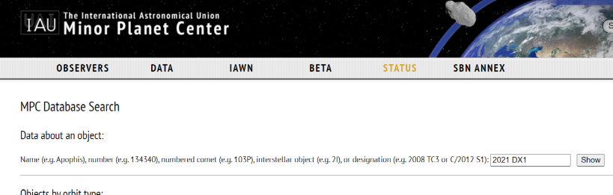
MPC Observations Database
A page will display showing lots of information about the object. Scroll down to the list of observations and select the “download” link.
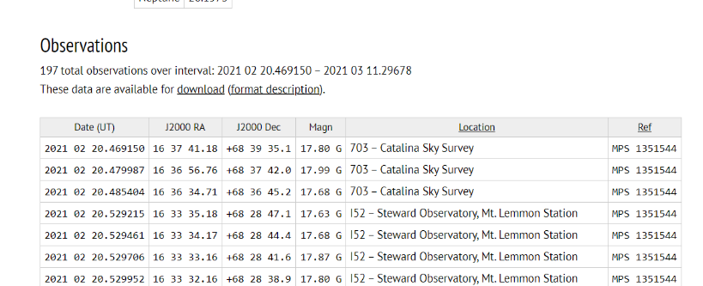
Observations list
This will take you to a plain text version of the observations list which you can save as a text file.
Open the text file and see what has arrived. If you have selected a low-number object, there could be a very large number of observations going back many decades. This will give Find_Orb indigestion! Delete all the observations further back than the last two or three oppositions or a few hundred observations over the last few years.
When you have cut your observations file down to size, copy the entire ADES Report from Astrometrica and paste it to the bottom of the observations file, then save.

Check your Residuals
Go to On Line Find_Orb.
Best not to get too worried about most of the stuff on this page. Go to the area where there is a Choose File button. Use that to select the file of observations you have prepared and select “Compute Orbit and Ephemeris”.
Find_Orb will now try to find an orbit that is optimised to satisfies all the observations as closely as possible. Output will be like a Minor Planet Electronic Circular (MPEC) – a document published by the MPC when it announces new discoveries, orbit updates and observations.
Scroll down to the section on “Residuals in arcseconds”. You should see your observations (from G40 or W88) near the end of the list. The two numbers next to them are your residuals in RA and Decl.
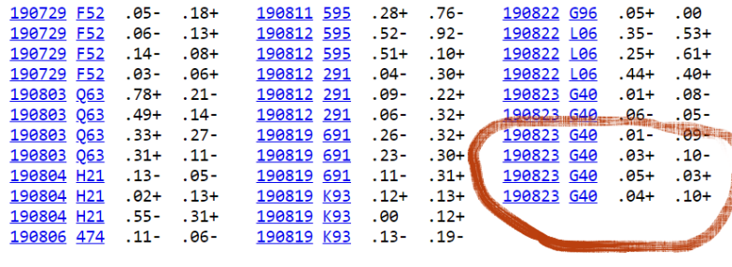
Residuals for G40
When you have reached this stage copy the Pseudo MPEC page into a file and email it to your A-Team tutor together with comments about why you chose that object, any problems experienced or questions. You will get feedback on the measurements as soon as possible.

Quality
If everything has gone reasonably well your residuals should be less than 1.0″. If they are less than 0.5″, well done!
If they are all consistently over 1″ there may be a good reason. If they are scattered (large and small, positive and negative), try doing the measurements again.
There will be lots more discussion in later tutorials about the quality of observations as demonstrated by their residuals.

Conclusion
Now you have completed the basic workflow.
The best thing to do is practice this with some other objects listed in What’s Observable? – maybe try some fainter ones. If you are comfortable doing this then proceed to Level 2, where we will look for some more interesting and challenging targets and learn some new tricks.
Originally published April 2014. Last update 22 Mar. 2024.
Tony Evans

